

database management systems

Cycle Sheet – 3

­­

Name: **VIBHU KUMAR SINGH**

Reg. No: **19BCE0215**

Teacher: **Nancy Victor**

**Creating Tables:**

Doctor:

create table Doctor(

doc_id varchar(20) primary key,

doc_name varchar(30) not null,

d_gender char(1),

constraint ck_d_gender check(d_gender = 'M' or d_gender = 'F' or d_gender = 'T'),

d_dob date not null,

specialist varchar(25),

qualification varchar(15),

d_Contact number(20),

d_Address varchar(50) not null,

d_dept_no varchar(20)

)

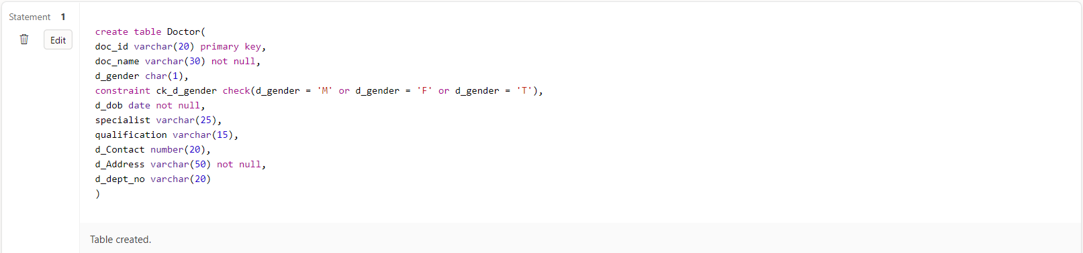

Department:

create table Department(

dept_no varchar(20) primary key,

dept_name varchar(30) not null,

room_no varchar(10),

floor number(5),

hod varchar(20),

constraint fk_hod foreign key(hod) references Doctor(doc_id),

estd_date date

) 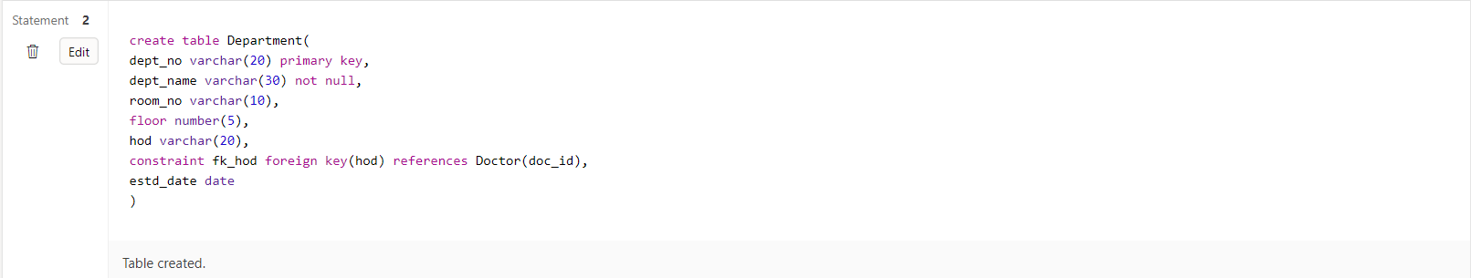

Staff:

create table Staff(

staff_id varchar(15) primary key,

staff_name varchar(25) not null,

category varchar(20),

designation varchar(15) not null,

s_dob date not null,

s_contact number(15),

s_address varchar(50),

s_dept_no varchar(10),

constraint fk_s_dept_no foreign key(s_dept_no) references Department(dept_no)

)

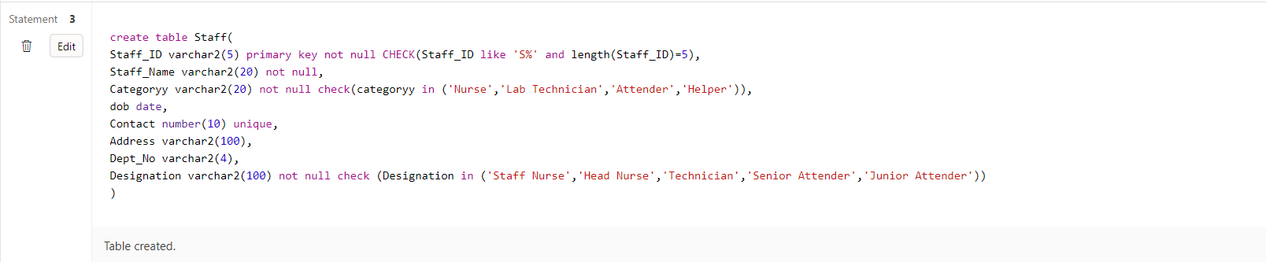

Patient:

create table Patient(

pat_id varchar(20) primary key,

pat_name varchar(30) not null,

p_dob date not null,

p_gender varchar(10) not null,

constraint ck_p_gender check(p_gender = 'M'or p_gender = 'F' or p_gender ='T'),

p_contact number(20),

p_address varchar(50) not null

)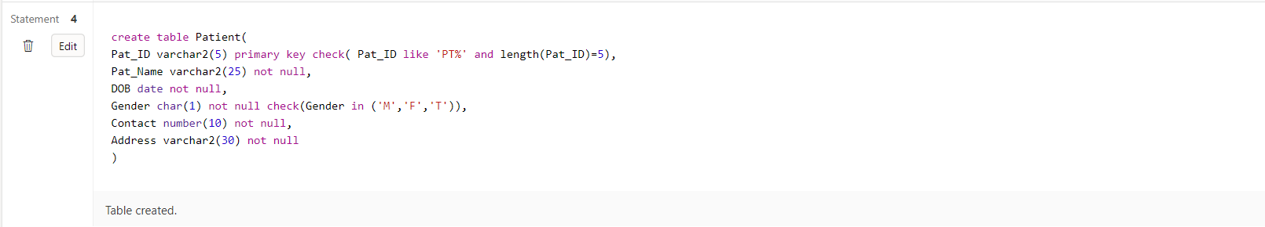

In_Patient:

create table In_Patient(

ip_id varchar(20),

doa date not null,

primary key(ip_id,doa),

bed_no varchar(10),

start_time date,

end_time date,

constraint fk_ip_id foreign key (ip_id) references Patient(pat_id)

)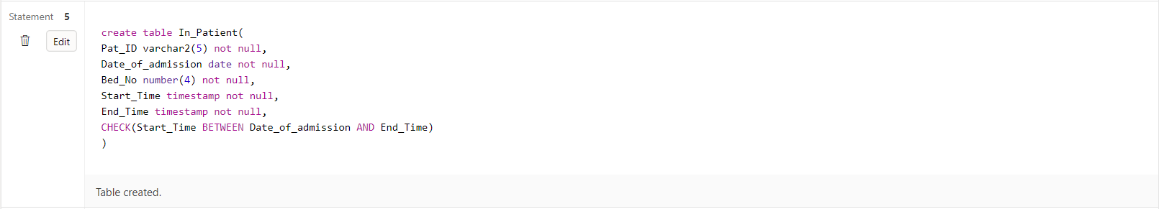

In_Patient_Prescription:

create table In_Patient_Prescription(

in_pat_id varchar(20) not null,

ip_pres_id varchar(20) not null,

primary key(in_pat_id,ip_pres_id),

constraint fk_pres_id foreign key(ip_pres_id) references Prescription(pres_id),

constraint fk_in_pat_id foreign key(in_pat_id) references Patient(pat_id)

)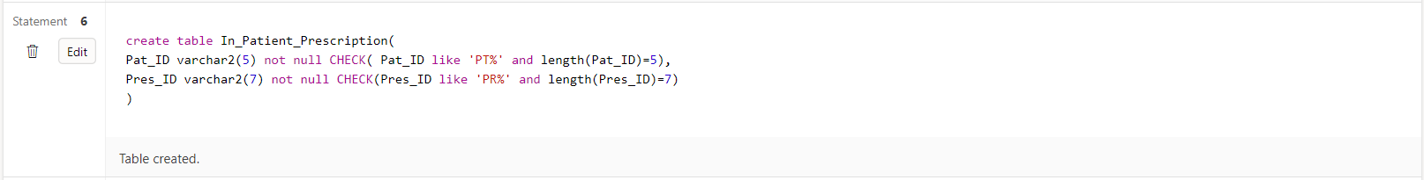

Appointment:

create table Appointment(

app_id varchar(20) primary key,

a_pat_id varchar(20),

constraint fk_a_pat_id foreign key(a_pat_id) references Patient(pat_id),

a_doc_id varchar(20),

constraint fk_a_doc_id foreign key(a_doc_id) references Doctor(doc_id),

nurse_id varchar(20),

constraint fk_nurse_id foreign key(nurse_id) references Staff(staff_id),

consult_room_no number(20),

a_date date not null,

a_time varchar(10) not null

)

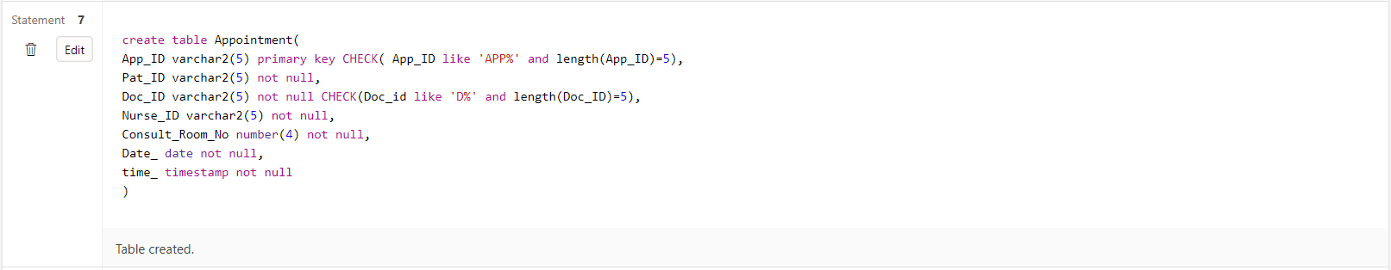

Prescription:

create table Prescription(

pres_id varchar(15) primary key,

p_app_id varchar(20),

constraint fk_p_app_id foreign key(p_app_id) references Appointment(app_id),

pres_date date not null,

pres_time varchar(10),

diagnosis_details varchar(20)

)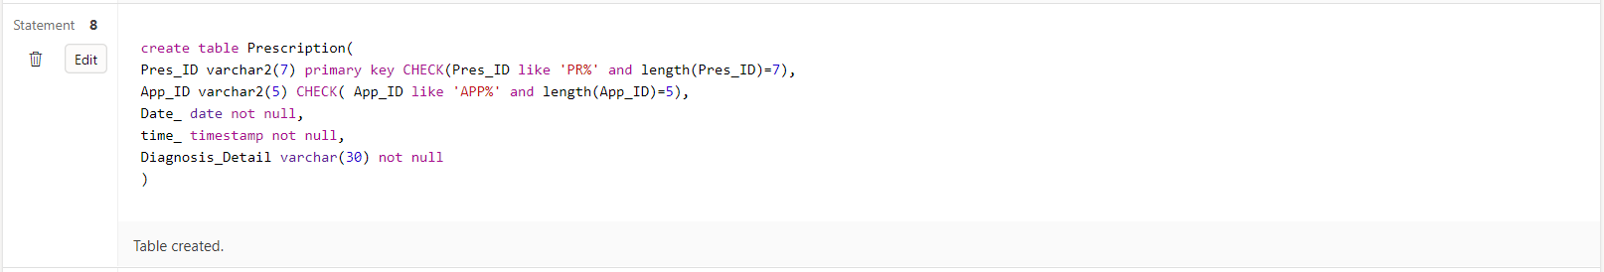

Prescribed_Medicines:

create table Prescribed_Medicines(

m_pres_id varchar(25) ,

constraint fk_m_pres_id foreign key (m_pres_id) references Prescription(pres_id),

medicine_name varchar(40) not null,

primary key(m_pres_id,medicine_name),

dosage varchar(20),

brand varchar(10)

)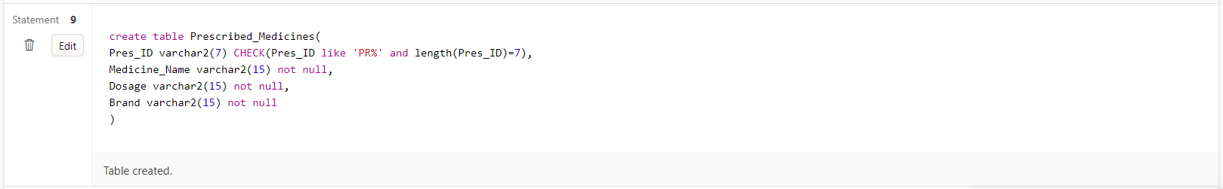

Hospital_Bill:

create table Hospital_Bill(

inv_no number(20),

inv_date date not null,

primary key(inv_no,inv_date),

i_pat_id varchar(20),

constraint fk_i_pat_id foreign key(i_pat_id) references Patient(pat_id),

bill_amount number(25),

payment_type varchar(25) not null,

discount number(20)

)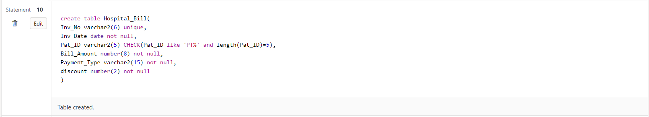

Lab_Tests:

create table Lab_Tests(

test_id varchar(20) primary key,

L_pat_id varchar(20),

constraint fk_L_pat_id foreign key(L_pat_id) references Patient(pat_id),

lab_date date,

lab_time varchar(10)

)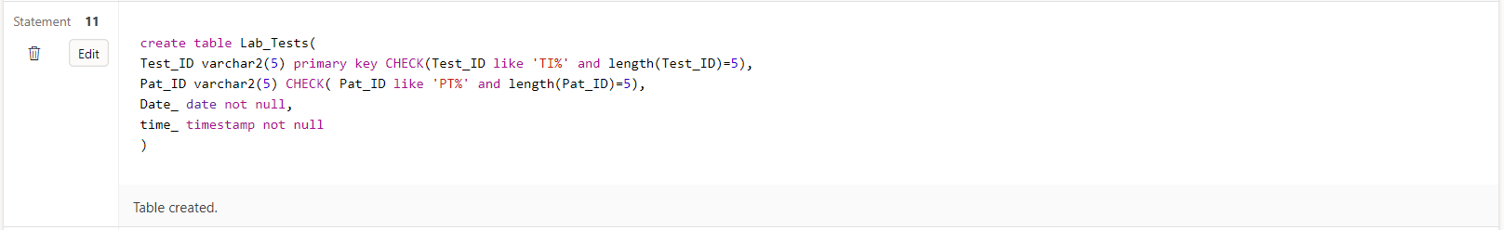

Test_Results:

create table Test_Results(

r_test_id varchar(20) ,

constraint fk_r_test_id foreign key (r_test_id) references Lab_Tests(test_id),

r_test_type_id varchar(20),

constraint fk_r_test_type_id foreign key(r_test_type_id) references test_types(tt_id),

primary key(r_test_id,r_test_type_id),

results varchar(20) not null

)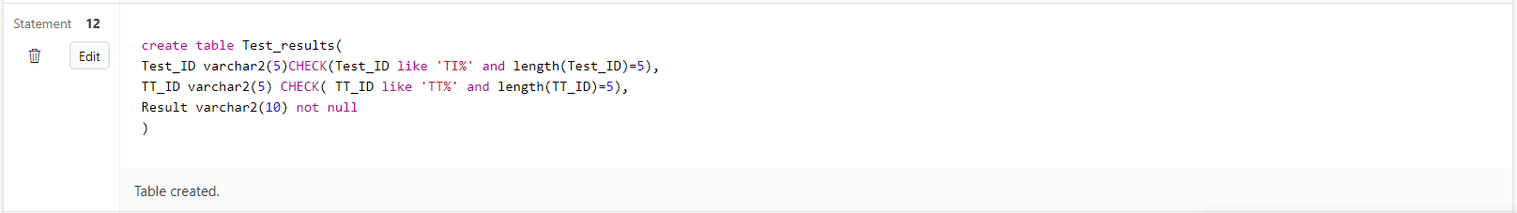

Test_Types:

create table test_types(

tt_id varchar(20) primary key,

description varchar(30),

low_value number(25),

high_value number(25),

test_method varchar(25),

technician varchar(20),

constraint fk_technician foreign key(technician) references Staff(staff_id)

)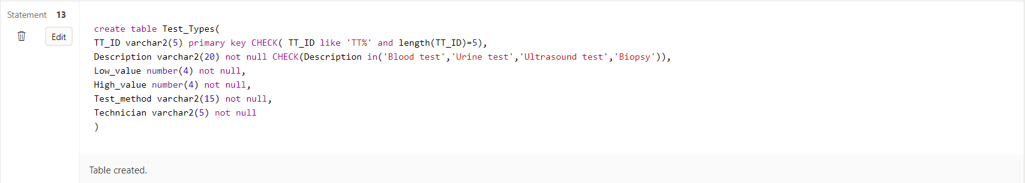

**SCHEMA:**

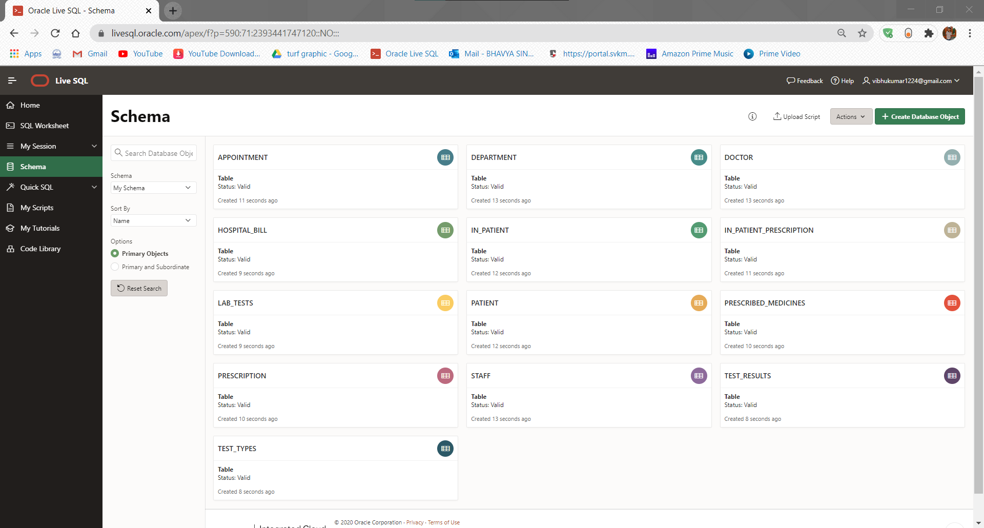

**Inserting Values:**

Doctor:

insert into Doctor values('D108','Vibhu Kumar','M','20-SEPTEMBER

1985','CARDIOLOGIST','MBBS',9926519823,'1,BAREILLY','D101');

insert into Doctor values('D105','Bhavya Singh','M','12-FEBRUARY-1980','NEUROLOGIST','BAMS',9254376189,'15,LUCKNOW','D103');

insert into Doctor values('D101','Sanjay Kumar','F','21-AUGUST-1989','NEPHROLOGIST','MD',976124512,'51,KANPUR','D101');

insert into Doctor values('D107','Aman Singh','M','01-JANUARY-1992','ONCOLOGIST','MD',8449268172,'95,AGRA','D190');

insert into Doctor values('D104','Paman Singh','M','21-DECEMBER-1991','GENERALMEDICINE','MD',8912678219,'102,PUNE','D101');

insert into Doctor values('D102','Tani Kaur','F','25-JUNE-1990','CARDIOLOGIST','MBBS',9363981256,'530,DELHI','D100');

insert into Doctor values('D106','Raghavan','M','03-FEBRUARY-1994','NEPHROLOGIST','MDS',9897268266,'17,MATHURA','D101');

insert into Doctor values('D103','Riya Patel','F','25-APRIL-1984','CARDIOLOGIST','MD',7904226737,'121,GWALIOR','D005');

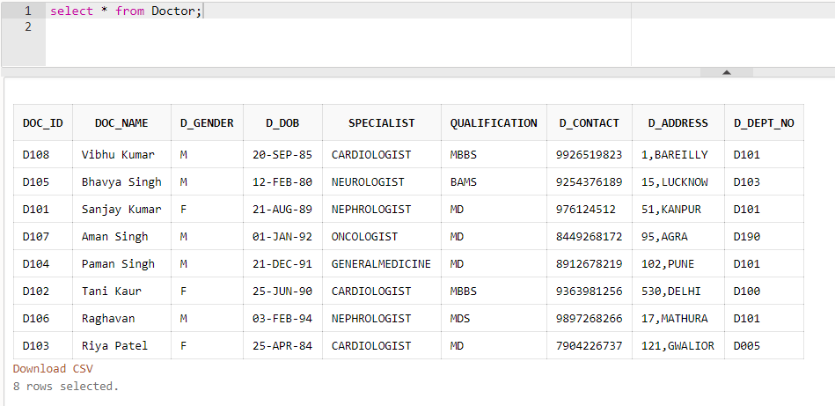

Department:

insert into Department values('D101','CARDIOLOGY','A-111',7,'D108','20-MARCH-2012');

insert into Department values('D103','NEUROLOGY','A-120',5,'D101','10-JANUARY-2011');

insert into Department values('D190','ONCOLOGY','A-005',9,'D105','19-DECEMBER-2019');

insert into Department values('D100','CARDIOLOGY','C-050',7,'D106','21-APRIL-2019');

insert into Department values('D005','GM','D-110',7,'D104','31-DECEMBER-2011');

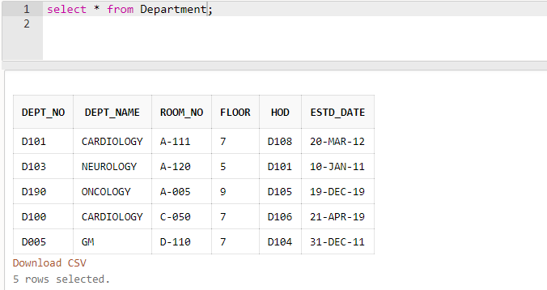

Staff:

insert into Staff values('S0001','Kirti','nurse','staff nurse','18-AUGUST-1998',9421862561,'BAREILLY','D101');

insert into Staff values('S0002','Swati Gangwar','nurse','staff nurse','05-SEPTEMBER-1999',9721765571,'LUCKNOW','D103');

insert into Staff values('S0003','Shivani Maurya','nurse','staff nurse','10-JUNE-1995',9421862561,'AGRA','D005');

insert into Staff values('S0004','Virat Singh','lab technician','technician','15-APRIL-1997',978945121,'MATHURA','D190');

insert into Staff values('S0005','Rohit Kashyap','lab technician','technician','18-DECEMBER-1998',978951124,'PILIBHIT','D190');

insert into Staff values('S0006','Deepanshu Gupta','cashier','staff cashier','11-DECEMBER-1994',9421862561,'MUMBAI','D101');

insert into Staff values('S0008','Manoj Kumar','ward boy','ward boy','29-AUGUST-1992',9787862561,'DELHI','D103');

insert into Staff values('S0009','Yash Jaiswal','security','staff security','06-DECEMBER-1996',9421862561,'GURGAON','D005');

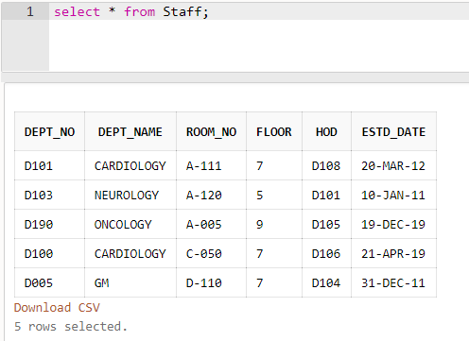

Patient:

insert into Patient values('P101','Vibhu Kumar','06-JULY-2000','M',9218357319,'52,BAREILLY');

insert into Patient values('P220','Tanuj','09-OCTOBER-1978','F',7841454511,'132,MUMBAI');

insert into Patient values('P103','Steve ','20-DECEMBER-1975','M',9751254454,'08,DELHI');

insert into Patient values('P104','Mani','15-JUNE-1995','M',944587122,'62,JHANSI');

insert into Patient values('P105','Fara Khan','19-DECEMBER-2014','F',9878987890,'12,GWALIOR');

insert into Patient values('P106','Gayle','25-MARCH-1990','M',944548412,'102,MATHURA');

insert into Patient values('P107','Mansi Jaiswal','07-JUNE-1994','F',9785458412,'190,BAREILLY');

insert into Patient values('P108','Karthik','21-AUGUST-1979','M',944548412,'06,KANPUR');

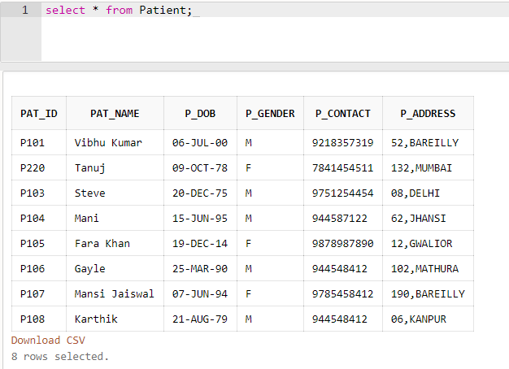

In_Patient:

insert into In_Patient values('P101', '11-MARCH-2017','B101','11-MARCH-2017','18-MARCH-2017');

insert into In_Patient values('P220', '10-JANUARY-2020' ,'B012','10-JANUARY-2020','30-JANUARY-2020');

insert into In_Patient values('P104', '28-FEBRUARY-2020' ,'B101','28-FEBRUARY-2020','15-MARCH-2020');

insert into In_Patient values('P105', '30-MARCH-2017','B015','30-MARCH-2017','09-APRIL-2017');

insert into In_Patient values('P106', '30-DECEMBER-2019','B001','30-DECEMBER-2019','15-JANUARY-2020');

insert into In_Patient values('P107','30-MARCH-2020','B019','30-MARCH-2020','17-APRIL-2020');

insert into In_Patient values('P103','29-MAY-2020','B101','29-MAY-2020','12-JUNE-2020');

insert into In_Patient values('P108','30-NOVEMBER-2019','B14','30-NOVEMBER-2019','30-DEC-2019');

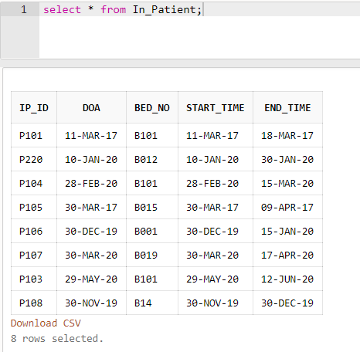

Appointment:

insert into Appointment values('A101','P101','D101','S0001',103,'12-MARCH-2017','13:00');

insert into Appointment values('A102','P220','D102','S0002',111,'11-JANUARY-2020','12:00');

insert into Appointment values('A103','P103','D103','S0003',100,'01-JANUARY-2020','17:00');

insert into Appointment values('A104','P104','D104','S0004',005,'18-FEBRUARY-2020','11:00');

insert into Appointment values('A105','P105','D105','S0005',120,'25-AUGUST-2019','08:00');

insert into Appointment values('A106','P106','D106','S0006',111,'01-MAY-2020','09:30');

insert into Appointment values('A107','P107','D107','S0008',111,'01-MAY-2020','10:15');

insert into Appointment values('A108','P108','D108','S0009',105,'01-MAY-2020','11:20');

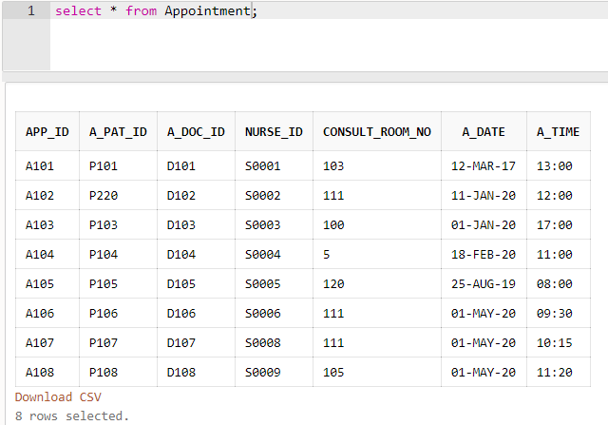

Precription:

insert into Prescription values('PR00001','A101', '12-MARCH-2017' ,'13:30','COUGH');

insert into Prescription values('PR00002','A102', '11-JANUARY-2020' ,'13:00','NEURAL ATTACK');

insert into Prescription values('PR00003','A103','02-JANUARY-2020','14:00','BILATERAL PNEUMONIA');

insert into Prescription values('PR00004','A104','18-FEBRUARY-2020','16:00','COUGH');

insert into Prescription values('PR00005','A105','25-AUGUST-2019','08:30','CARDIAC ARREST');

insert into Prescription values('PR00006','A106','01-MAY-2020','10:15','ACCIDENT');

insert into Prescription values('PR00007','A107','01-MAY-2020','11:25','COUGH');

insert into Prescription values('PR00008','A108','01-MAY-2020','12:30','CARDIAC ARREST');

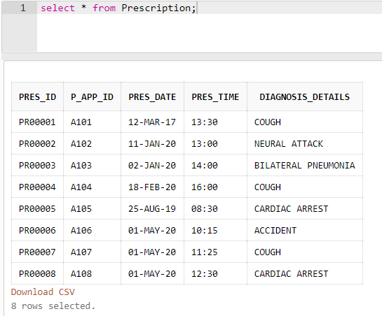

In_Patient_Prescription:

insert into In_Patient_Prescription values('P101','PR00001');

insert into In_Patient_Prescription values('P220','PR00002');

insert into In_Patient_Prescription values('P103','PR00003');

insert into In_Patient_Prescription values('P104','PR00004');

insert into In_Patient_Prescription values('P105','PR00005');

insert into In_Patient_Prescription values('P106','PR00006');

insert into In_Patient_Prescription values('P107','PR00007');

insert into In_Patient_Prescription values('P108','PR00008');

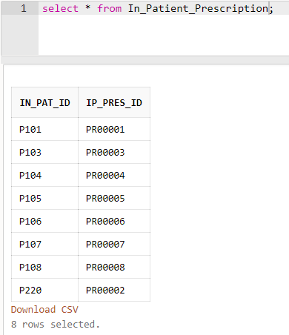

Prescribed_Medicines:

insert into Prescribed_Medicines values('PR00001','AMOXICILLIN','TWICE A DAY','Ranbaxy');

insert into Prescribed_Medicines values('PR00002','AMANTADINE','ONCE A DAY','DEF');

insert into Prescribed_Medicines values('PR00003','MACROLIDE','ONCE A DAY','Ranbaxy');

insert into Prescribed_Medicines values('PR00004','AMOXICILLIN','THRICE A DAY','XYZ');

insert into Prescribed_Medicines values('PR00005','LIDOCAINE','TWICE A DAY','JKL');

insert into Prescribed_Medicines values('PR00006','TYLENOL','ONCE A DAY','MNO');

insert into Prescribed_Medicines values('PR00007','AMOXICILLIN','THRICE A DAY','PQR');

insert into Prescribed_Medicines values('PR00008','LIDOCAINE','TWICE A DAY','Ranbaxy');

insert into Hospital_Bill values(1020,'18-MARCH-2017','P101',10000,'CASH',12);

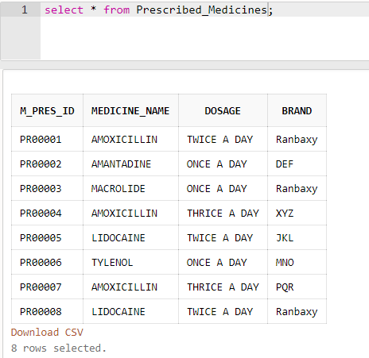

Hospital_Bill:

insert into Hospital_Bill values(1021,'30-JANUARY-2020','P220',200000,'CREDIT CARD',15);

insert into Hospital_Bill values(1022,'30-MAY-2020','P103',11000,'DEBIT CARD',20);

insert into Hospital_Bill values(1023,'28-FEBRUARY-2020','P104',15000,'DEBIT CARD',13);

insert into Hospital_Bill values(1024,'30-JANUARY-2020','P105',20000,'CREDIT CARD',05);

insert into Hospital_Bill values(1025,'09-APRIL-2017','P106',7000,'CASH',22);

insert into Hospital_Bill values(1026,'17-APRIL-2020','P107',3500,'CASH',18);

insert into Hospital_Bill values(1027,'12-JUNE-2020','P108',42000,'DEBIT CARD',10);

insert into Hospital_Bill values(1028,'05-JUNE-2020','P103',2000,'DEBIT CARD',21);

insert into Hospital_Bill values(1029,'09-JUNE-2020','P103',15000,'DEBIT CARD',20);

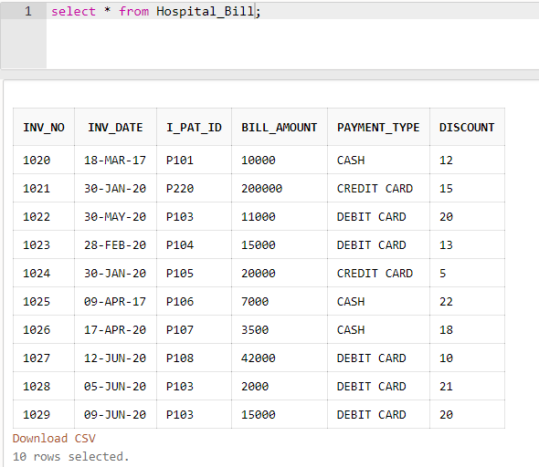

Lab_Tests:

insert into Lab_Tests values('T0001','P101','13-MARCH-2017','11:00');

insert into Lab_Tests values('T0002','P220','12-JANUARY-2020','09:00');

insert into Lab_Tests values('T0003','P103','03-JANUARY-2020','10:00');

insert into Lab_Tests values('T0004','P104','19-FEBRUARY-2020','09:30');

insert into Lab_Tests values('T0005','P105','26-AUGUST-2019','16:00');

insert into Lab_Tests values('T0006','P106','02-MAY-2020','17:00');

insert into Lab_Tests values('T0007','P107','03-MAY-2020','13:00');

insert into Lab_Tests values('T0008','P108','03-MAY-2020','14:00');

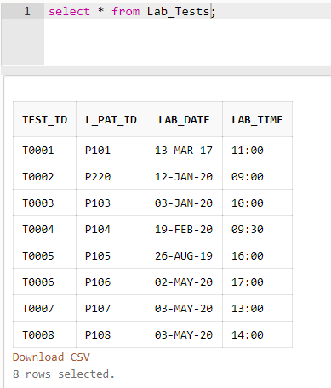

Test_Types:

insert into test_types values('TT0001','URINE TEST',26,74,'LAB','S0001');

insert into test_types values('TT0002','CT',15,20,'LAB','S0002');

insert into test_types values('TT0003','Blood Sugar Level',18,28,'LAB','S0003');

insert into test_types values('TT0004','XRAY TEST',38,52,'LAB','S0001');

insert into test_types values('TT0005','CT TEST',12.5,14.2,'LAB','S0005');

insert into test_types values('TT0006','URINE TEST',12,22,'LAB','S0001');

insert into test_types values('TT0007','XRAY',19,29,'LAB','S0009');

insert into test_types values('TT0008','Blood Glucose Level',2,10,'LAB','S0008');

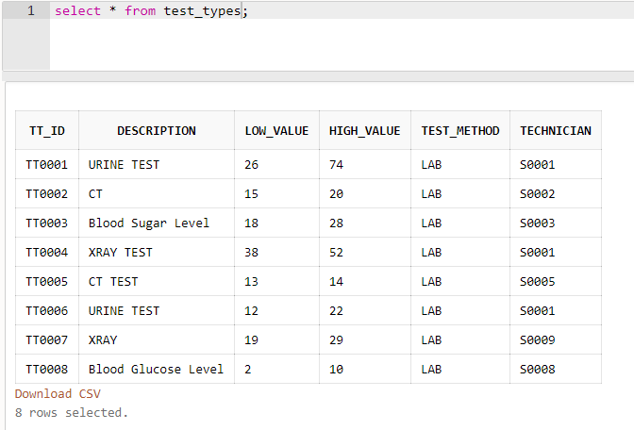

Test_Results:

insert into Test_Results values('T0001','TT0001','POSITIVE');

insert into Test_Results values('T0002','TT0002','NEGATIVE');

insert into Test_Results values('T0003','TT0003','NEGATIVE');

insert into Test_Results values('T0004','TT0004','POSITIVE');

insert into Test_Results values('T0005','TT0005','NEGATIVE');

insert into Test_Results values('T0006','TT0006','NEGATIVE');

insert into Test_Results values('T0007','TT0007','POSITIVE');

insert into Test_Results values('T0008','TT0008','NEGATIVE');

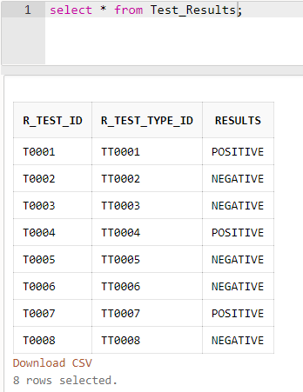

**Questions:**

**Q1.Write a PL/SQL program to implement a simple calculator.**

**A1.**

declare

a number :=10;

b number :=2;

c number;

begin

c:=a+b;

dbms_output.put_line('a+b = ');

dbms_output.put_line(c);

c:= a-b;

dbms_output.put_line('a-b = ');

dbms_output.put_line(c);

c:= a*b;

dbms_output.put_line('a*b = ');

dbms_output.put_line(c);

c:= a/b;

dbms_output.put_line('a/b = ');

dbms_output.put_line(c);

end;

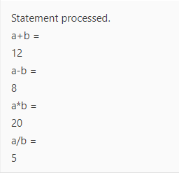

**Q2.Write a PL/SQL program to practice reading the record from a table into local variables using different data types and %TYPE and display the same using locally declared variables.**

**A2.**

declare

d_name Department.dept_name%type;

hod_id Department.hod%type;

begin

select dept_name,hod into d_name,hod_id from Department where dept_name = 'NEUROLOGY';

dbms_output.put_line('Department name is: '|| d_name || ' and ID of HOD of this dept is: ' ||hod_id);

end;

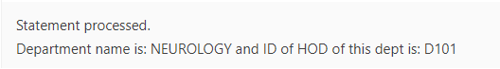

**Q3.Write a PL/SQL program to find the number of doctors in a given department with a given qualification (read values for department and qualification from user during runtime). If number is more than the number of doctors in that department with other qualifications then display ‘Well qualified’ else ‘Qualified’.**

**A3.**

set serveroutput on;

DECLARE

x int;

y int;

dept doctor.dept_no%type;

qual doctor.qualification%type;

BEGIN

dept:='&dept';

qual='&qual';

SELECT COUNT (Doc_id) into x from Doctor where Dept_no=dept and Qualification=qual;

SELECT COUNT (Doc_id) into y from Doctor where Dept_no=dept and Qualification=qual;

DBMS_OUTPUT.PUT_LINE('Total no of Doctors in given department with given qualification are'||x);

if x>y then DBMS_OUTPUR.PUT_LINE('Well Qualified');

else DBMS_OUTPUR.PUT_LINE('Qualified');

end if;

END;

/

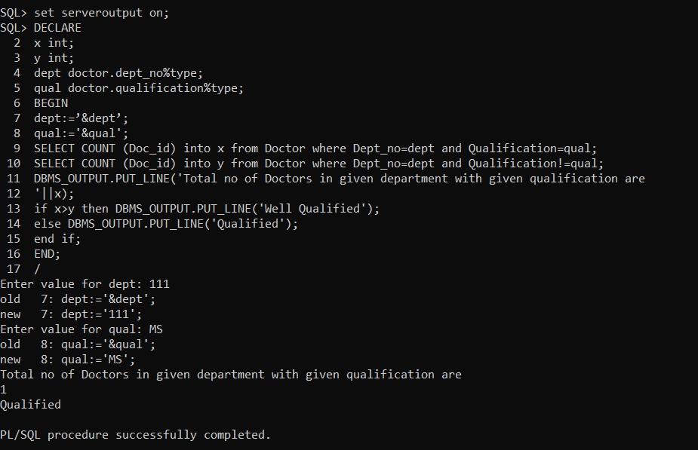

**Q4.Write a PL/SQL program to insert records into any of the tables in your database.**

**A4.**

--before insertion

select* from Department

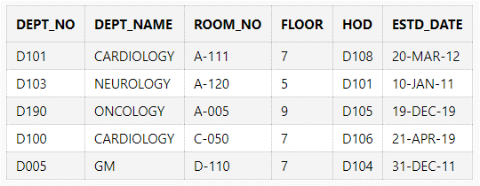

begin

insert into Department

values('D006','ONCOLOGY','D-111',7,'D101','27-DECEMBER-2010');

insert into Department

values('D102','NEUROLOGY','C-051',9,'D105','15-NOVEMBER-2007');

end;

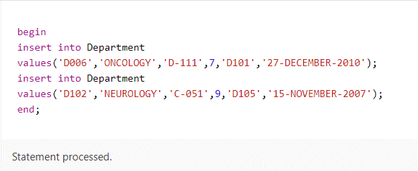

--after insertion

select* from Department

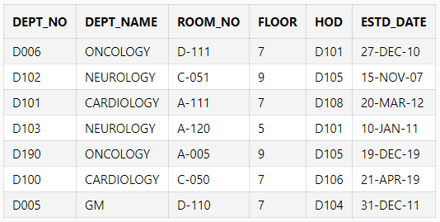

**Q5.Create a function to find the factorial of a given number.**

**A5.**

create or replace function factorial(x number) return number is

fact number:=1;

begin

for i in 1..x loop

fact:=fact*i;

end loop;

return fact;

end;

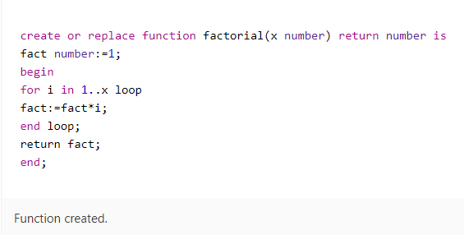

declare

output number(11);

begin

output :=factorial(11);

dbms_output.put_line('Factorial is: '|| output);

end;

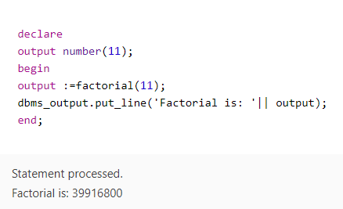

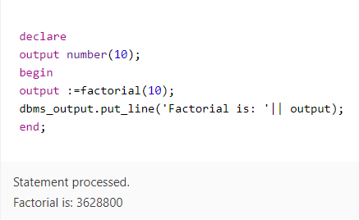

**Q6.Create a function DOC_COUNT to find the number of doctors in the given department. Use the department name as the input parameter for the function.**

**A6.**

create or replace function doct_count(dt_name varchar2) return number is

doc_c number;

begin

select count(1) into doc_c from Doctor dr inner join Department dt

on dr.d_dept_no=dt.dept_no where dt.dept_name=dt_name;

return doc_c;

end;

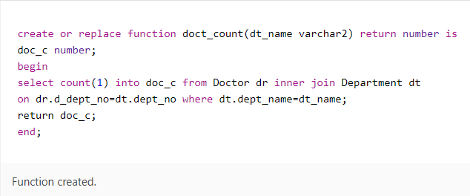

declare

num_ number;

begin

num_:=doct_count('GM');

dbms_output.put_line('Number of general medine practioners: '|| num_);

end;

